Medical History Form
Welcome to Centennial Sports and Physical Therapy. Please take a moment to complete your medical history as accurately as possible. This information allows us to provide you with the most efficient and effective care specific to your personal needs. Thank You

Name: Age: Occupation: ______
Date of injury/onset: ___________Leisure activities: __________________________
How were you injured? _______________________________________________________________________________ Patient’s Chief Complaint:_____________________________________________________________________________
Surgeries related to this injury? No Yes procedure: Date of Surgery:
Please list any surgeries or other conditions that we should be aware of: ______

Tests (X-ray, MRI):_________________________________
Are you sensitive to latex? Yes No Do you have a Pacemaker? Yes No
Do you Smoke? Yes No
Do you exercise regularly? Yes No Times a week______________ Specific exercise____________________ Have you ever taken steroid medication for any medical conditions? Yes No Have you ever taken blood thinning or anticoagulant medications for any medical conditions? Yes No
Have you RECENTLY noted any of the following (check all that apply)?

Balance issues while walking
Bowel / Bladder changes
Constipation
Cough
Diarrhea
Difficulty swallowing
Dizziness / Lightheadedness
Fainting
Falls
Fatigue
Fever / Chills / Night sweats
Headaches
Heartburn / Indigestion
Nausea or vomiting
Numbness or tingling
Shortness of breath
Vision or hearing problems
Weakness
Weight loss or gain

Have you EVER been diagnosed with any of the following conditions (check all that apply)?

Allergies__________________
____________________________
Anemia
Arthritis
Asthma
Bladder/Urinary tract infection
Blood Clots
Bowel or bladder problems
Bone or joint infection
Cancer
Chemical dependency
Chest pain / Angina
Circulation problems
Depression
Diabetes
Emphysema / Bronchitis
Eye problems / Infection
Fibromyalgia
Heart Problems
Hepatitis
High blood Pressure
Kidney Disease
Liver problems
Lung problems
Multiple Sclerosis
Numbness or tingling
Osteoporosis / Osteopenia
Pelvic inflammatory disease
Reproductive condition/Change
Seizures
Stroke
Thyroid problems
Ulcers

Other:

During the past month have you been feeling down, depressed or hopeless? Yes No
During the past month have you been bothered by having little interest or pleasure in doing things? Yes No
Is this something with which you would like help? Yes Yes, but not today No
Are you currently taking any medications? (Please list or attach a list)

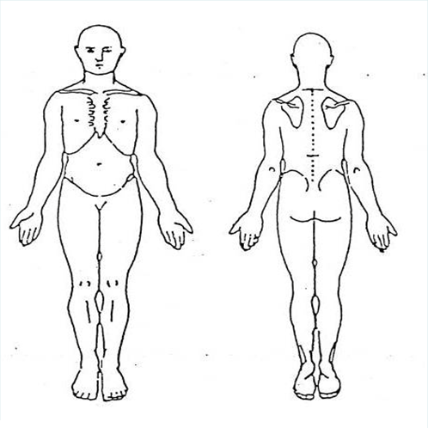
Please use the diagram below to mark where you feel your symptoms and comment as you see appropriate, on the space provided

My symptoms currently: Come & Go Are Constant Are constant but change with activity
My symptoms are currently: Getting better Getting Worse Staying about the same

How are you currently able to sleep at night due to your symptoms?
No problem sleeping Difficulty falling asleep Awakened by pain Sleep only with medication
When are your symptoms worst? Morning Evening Night At rest After Exercise
When are your symptoms best? Morning Evening Night At rest After Exercise

Are there any other activities you are unable to do or are having difficulty with as a result of your problem? List & rate on the scale: (Unable to perform 0 1 2 3 4 5 6 7 8 9 10 (Able to perform activity at pre-injury level)
1) Rating: ________
2) Rating: ________

3) Rating: ________

Patient Specific Functional Scale (PSFS) Avg: _______

How did you decide to attend Centennial Sports and Physical therapy?

___Doctor ___Return Client __Friend or Relative ___Advertisement Other:____________________

